We have seen some powerful forms of types in this chapter: recursive types defined using algebraic type definitions, generic types and even function types. Recall also that Star only requires programmers to explicitly declare the types of top-level variables and functions. It is worth pausing a little to see how this might be done.
Recall our original factorial function:
<$Scr_Ps::0>fact(0) => 1.
fact(N) => N*fact(N-1).
<!$Scr_Ps::0>The compiler is able to compute the types of the various variables automatically through a process known as type inference. Type inference may seem magical, but is actually (mostly) quite simple. Let us take a look at the expression:
<$Scr_Ps::0>N-1
<!$Scr_Ps::0>which is buried within the recursive call in fact. Although it looks like a special operator, Star does not treat arithmetic expressions in a special way; the <$Scr_Cs::3>-<!$Scr_Cs::3> function is just a function from numbers to numbers; its type is given by:
<$Scr_Ps::0> (-) : all t ~~ arithmetic[t] |: (t,t)=>t
<!$Scr_Ps::0>However, we should simplify this type a little in order to make the explanation of type inference a little simpler. In what follows, we assume that the type of <$Scr_Cs::3>(-)<!$Scr_Cs::3> is:
<$Scr_Ps::0>(-) : (integer,integer)=>integer
<!$Scr_Ps::0>Type inference proceeds by using special type inference rules which relate expressions to types, in this case the applicable rule is that a function application is consistent if the function’s parameter types are consistent with the types of the actual arguments. If they are consistent, then the type of the function application is the return type of the function.
The type inference process initially gives every variable an unknown type — represented by a new type variable not appearing anywhere else. For our tiny <$Scr_Cs::3>N-1<!$Scr_Cs::3> example, we will give <$Scr_Cs::3>N<!$Scr_Cs::3> the type <$Scr_Cs::3>tN<!$Scr_Cs::3>.
The (-) function has two arguments whose types can be expressed as a tuple of types:
<$Scr_Ps::0>(integer,integer)
<!$Scr_Ps::0>and the types of the actual arguments are also a tuple:
<$Scr_Ps::0>(tN,integer)
<!$Scr_Ps::0>In order for the expression to be type correct, the actual types of the arguments must be consistent with the expected types of the function; which we can do by making them the same. There is a particular process used to do this — called unification.
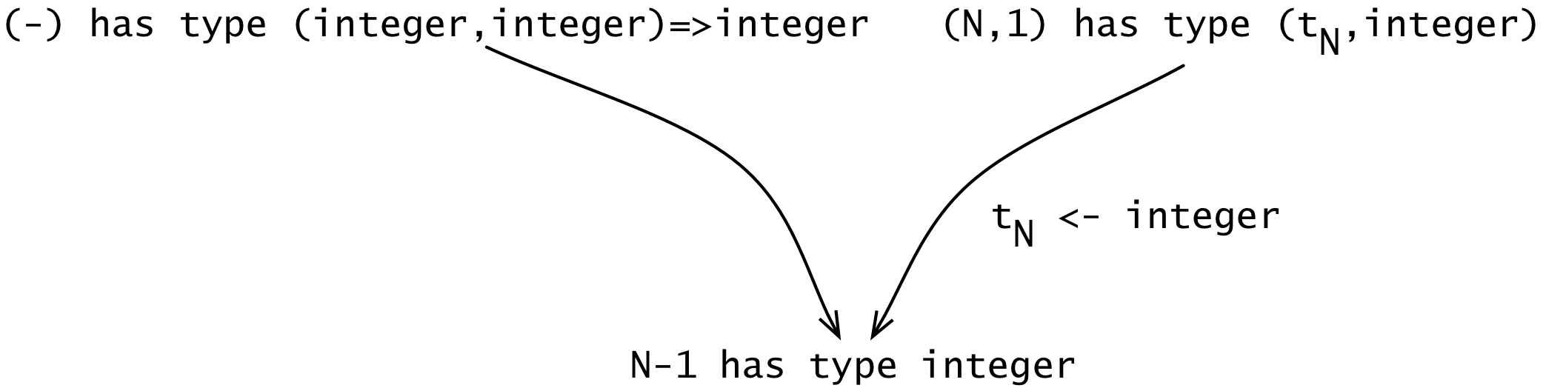
<$Scr_Ps::1>Inferring the Type of N-1
<!$Scr_Ps::1><$Scr_Ps::2>Unification
An algorithm that replaces variables with values in such a way as to make two terms identical.
<!$Scr_Ps::2>Unification matches equals with equals and handles (type) variables by substitutions — for example, we can make these two type expressions equal by binding the type variable tN to <$Scr_Cs::3>integer<!$Scr_Cs::3>.
We initially picked the type of N to be an arbitrary type variable, but the process of checking consistency leads us to refine this and make the type concrete. I.e., the use of N in a context where an integer is expected is enough to allow the compiler to infer that the type of N is indeed <$Scr_Cs::3>integer<!$Scr_Cs::3> and not tN.
Of course, if there are multiple occurrences of N then each of those occurrences must also be consistent with <$Scr_Cs::3>integer<!$Scr_Cs::3>; and if an occurrence is not consistent then the compiler will report an error — a given expression may only have one type!
The bottom line is that Star’s types are based on a combination of unification for comparing types and a series of type rules that have the effect of introducing constraints on types based on which language features the programmer uses. The type checker is really a constraint solver: if the constraints are not satisfiable (for example by trying to ‘call’ a variable and add a number to it) then there is a type error in the program.
The magic of type inference arises because it turns out that solving these constraints is sufficient for robustly type checking programs.
A sharp-eyed reader will notice that Star’s type system is different in nature to that found (say) in OO languages. In Star’s type system, types are considered to be consistent in Star if they are equal. This is quite different to the notion of consistency in OO languages where an argument to a function is consistent if its type is a sub-type of the expected type.
However, we would note that the apparent restriction to the type system imposed by type equality is much less severe in practice than in theory — and that OO languages’ type systems also incorporate some of the same restrictions.
We are only able to scratch the surface of the type system here. It is certainly true that — like many modern functional languages — Star’s type system is complex and subtle. The primary motivation for this complexity is to reduce the burden for the programmer: by being able to infer types automatically, and by being able to address many programming subtleties, the type system comes to be seen as the programmer’s friend rather than as an obstacle to be ‘gotten around’.

